年级科目 | 2024新人教版七上英语  科 目  英语
授课名称 | Unit 4 My Favorite Subject
授课课时 | 第四课时Section B 1a-2b  Section A (1a-2d) What is fun in a yard?
授课类型 | Reading and writing: What can you learn from different subjects?
授课教师 | 方子越（安庆市外国语学校西校区）
一、教材分析 Analysis of teaching material
What:本课语篇是一篇记叙文，文章主要介绍了迈克和吴彬彬最喜欢的学科及理由。两篇文章均以第一人称叙述，描述了两位不同国籍的学生对自己学习生活的介绍，包括所学的科目、喜欢的科目及其原因，以及对未来的职业规划。
Why:这两篇文章的写作目的在于分享学生的学习经历和兴趣，通过对所学科目的描述，展现了学生对学习的热情和对未来的憧憬。
How:文章通过使用简单明了的语句和词汇，让读者能够直观地了解作者描述的场景和情感。在写作手法方面，两篇文章都采用了直接叙述的方式，通过描述具体的学习经历和感受，使读者能够直观地了解到学生的真实想法。
二、教学内容 Teaching content
（1）能够快速阅读获取文章结构和主旨大意。
（2）能够慢速阅读获取细节信息。获取短文中有关迈克和吴彬彬喜欢学科及理由的基本信息，梳理、概括表示他们喜欢学科信息及理由的介绍，借助可视化图形呈现结构化知识。
（3）基于结构化知识和语篇主题图，运用目标语言，运用第三人称视角复述文章内容。
（4）分析、评价迈克和吴彬彬的行为和观点，结合自己的实际情况，阐述自己喜欢的学科，并阐述理由，在班级前进行展示。
三、教学目标Teaching objectives
Language Abilities (语言能力)
(1)Learn to master the new words, phrases and sentences.
(2)Learn to read and understand the content of the text, and write about their own class schedules and ideas about subjects and future job.
Learning Abilities (学习能力)
(1)Learn to get the main idea and some details by fast reading and careful reading.
(2)Learn to get information and organize their writing by using reading strategies and imitate its structure for their writing.
Thinking Qualities (思维品质)
(1)Learn to stimulate the interest of English learning.
(2)Learn to lead Ss to express their thoughts.
Cultural Awareness (文化意识)
(1)Learn to recognize the importance and differences of various subjects and career options.
四、教学重难点Teaching important and difficult points
Teaching important points: Learn to read and understand the content of the text, and write about their own class schedules and ideas about subjects and future job.
Teaching difficult points: Learn to get information and organize their writing by using reading strategies and imitate its structure for their writing.
五、教学步骤Teaching procedures
Step1. Lead in
Step2. Pre-reading
Step3. While-reading
Step4. Post-reading
Step5.Homework
六、教学评一体化教学过程设计Teaching process
教学步骤 | 教学活动 |  | 效果评价
Step1. Lead in | - Guessing time:Invite students to guess what subject it is by giving some tips about different subjects.  【设计目的】通过猜谜游戏的方式，导入本节课“学科”主题，引发学生兴趣，活跃课堂气氛。 |  | 观察学生是否认真阅读提示，是否进入课堂状态。
Step2. Pre-reading | 1.What subject do you study this term?  Sentence pattern: This term, I study…  【设计目的】联系实际情况，引导学生自主说出本学期学习的科目名称,同Unit 4 Section A部分衔接，并为后面的阅读任务奠定基础。  2.Pair work: What’s your favourite subject and why?  Let students try to discuss their favourite subjects and reasons with their partners by using following structure.  -Student A : What’s your favorite subject?  -Student B : My favorite subject is…  -Student A : Why do you like…?  -Student B : Because it’s …  【设计目的】通过讨论及对话的形式，在锻炼学生口语表达的同时，为后面的Post-reading环节进行铺垫。 |  | 观察学生是否能用英语准确地表达出所学的各个科目。  观察学生是否能快速表达出自己对最喜欢科目的喜爱原因。
Step3.While-reading  Step4.Post  -reading  Step5. Homework | 1.Fast reading:  (1)Look at the text quickly and answer the questions.  ①What kind of texts are they?  A. Emails. B. Online news. C. Online posts (帖子).  ②Where are the texts from?  A. They’re from the Internet.  B. They’re from a book.  C. They’re from a magazine.  - What’re their favourite subjects? How can you know them?  【设计目的】提升学生观察细节、快速阅读找准问题答案的能力。学生通过观察文体结构，根据排版结构及细节单词得知问题的答案。  (2)Read the beginning of this text.  ①Underline the subjects each students has.  Mike has…  Binbin has…  ②What subjects do Mike and Binbin both have?  They both have_____________.  ③What different subjects do the study?  Mike also studies _________________.  Binbin also studies _______________.  【设计目的】通过快速阅读、抓取关键词的方式获取信息，将文章中出现的人物所有学科、共同的学科和不同的学科找出，准确、快速地完成任务。  1.Careful reading:  - Listen to Mike’s post and answer the questions.  ①What’s Mike’s favourite subject and why?  ②How does Mike feel about music?  ③What does the music teacher do to make the students happy?  -Among your teachers, which one do you think is excellent?  【设计目的】学生阅读文章，画出Mike相关学科信息。  提升学生快速阅读，关键定位的能力。  - Retell Mike’s post with the blanks.  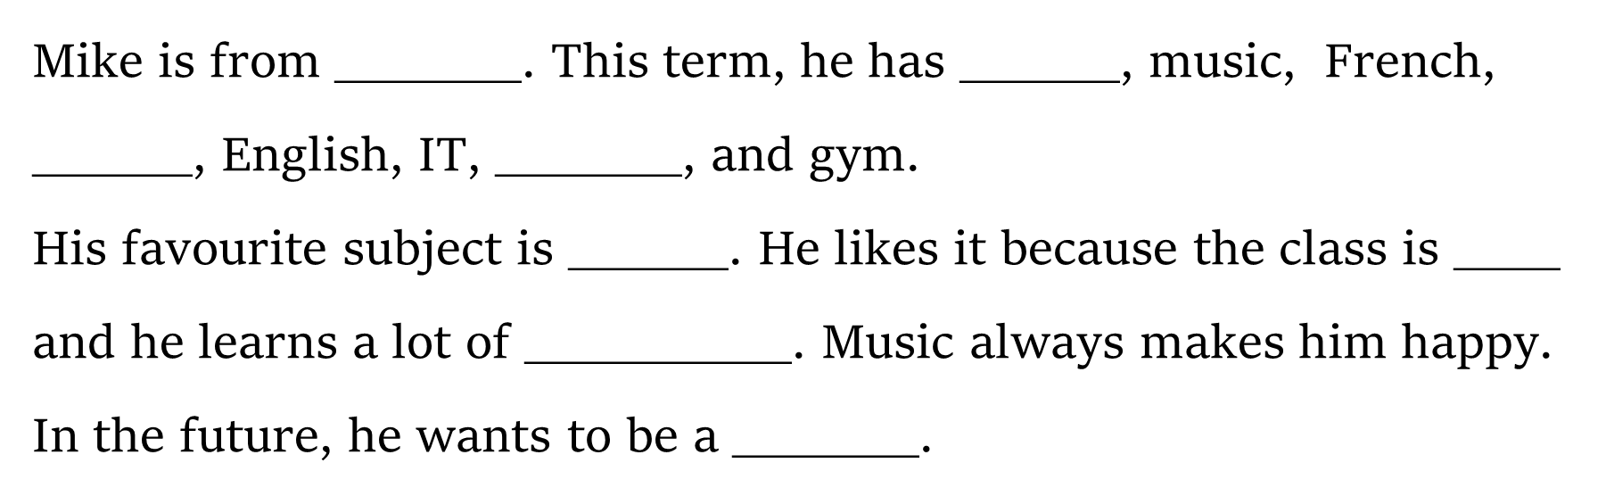  【设计目的】通过快速阅读、抓取关键词的方式获取信息，准确、快速地完成任务。  (3)Read Binbin’s post and complete the table. And then make students analysis the aspects of different reasons.  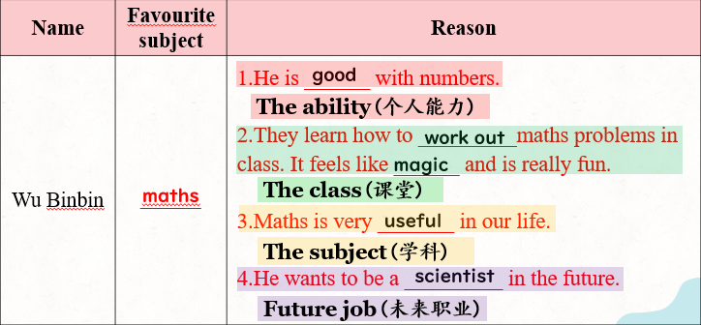  【设计目的】引导学生分析不同理由的角度，系统化梳理文章内容。提升学生快速阅读和仔细阅读的能力。并为下一步输出环节做铺垫。  - Complete the mind map with your own information. Then invite some of students to share their mind maps with the class.  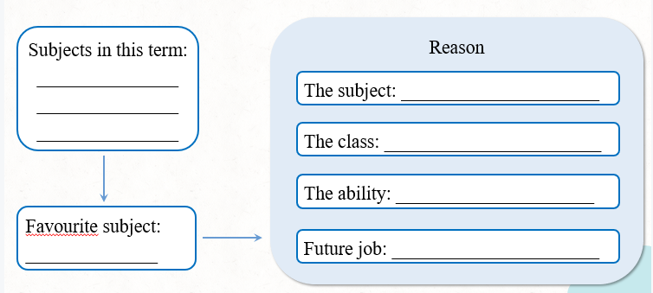  【设计目的】用思维导图的方式帮助学生梳理自己喜欢的科目及不同角度的原因，为下一步写作打好基础，使成文更加流利顺畅。  - Try to write a message by using your own information.  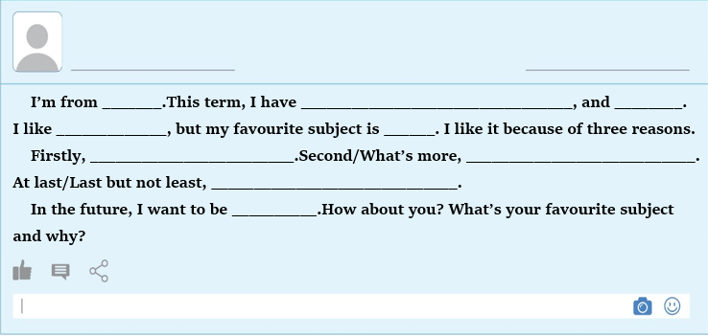  【设计目的】应用实践，根据所学内容和自己的实际情况  讨论后完成最终短文，引导学生内化结构化新知和关键语言，学习和分析与本主题相关的有效语言表达。  - The teacher will ask a question,“Can we only learn the subjects we like?” Then the teacher will show some excellent students of Anqing Foreign Language School to make students know the importance of learning different subjects. And let students know every subject is important.  【设计目的】情感引导，让学生了解每门学科的重要性，要齐头并进，学好每门科目。引导学生进行超越语篇、联系实际生活的活动，根据新情境整合运用相关语言表达,推动迁移创新。  1.Must do:  (1)Write a passage to introduce your favourite subjects and reasons;  (2)Share your passage with your classmates and friends.  2.Try to do:  Search for more information about different subjects in different countries.  【设计目的】检查学生对本节课重点知识的掌握和应用。 |  | 观察学生能否在教师的指导下快速关注到细节并找到问题的答案。  观察学生能否在文章中快速找出细节信息，把对应到文章的内容处标注出来。  观察学生能否运用寻读策略找到Mike最喜欢的学科及原因、以及其他问题。学生能否准确地、快速地划出答案。  观察学生是否会快速转换人称，从第一人称叙述转为第三人称重述。并快速定位到关键词部分。  观察学生是否能根据文章内容填空，拼写是否正确。  观察学生是否认真了解每个人最喜欢的科目及其理由,并仿照其写出自己的架构。  学生是否会表达自己对学科的观点，是否会根据自己实际情况完成短文所缺内容，拼写是否正确。  学生是否理解每门学科的重要性。
七、板书设计Blackboard design
Unit 4 My Favorite Subject
Section B 1a-2b
What can you learn from different subjects?
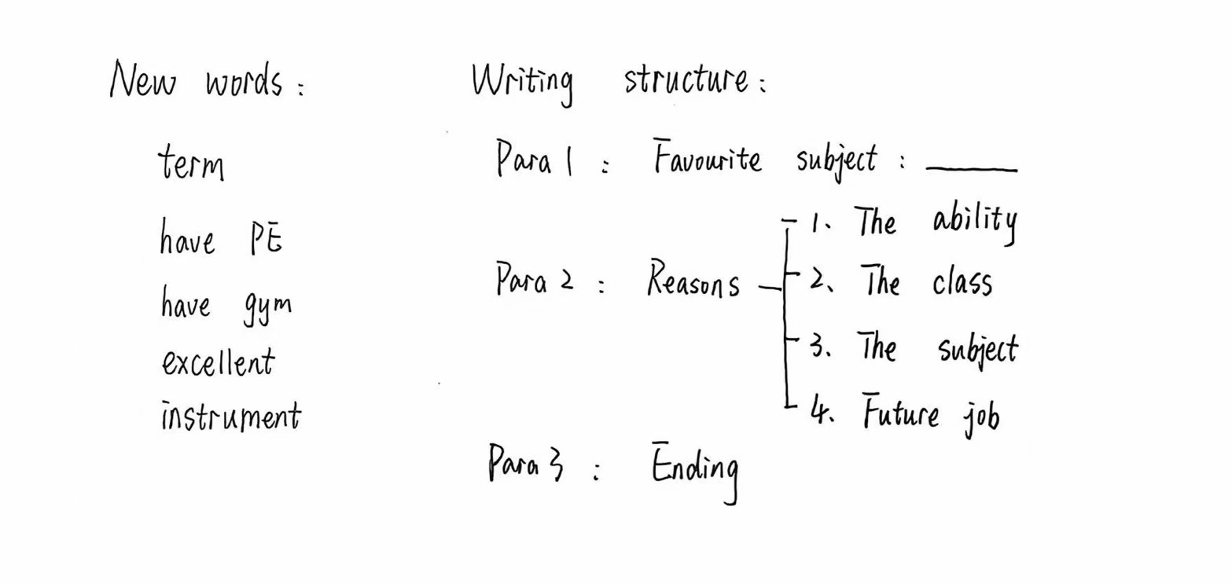

八、家庭作业Homework
必做Must-do |  | 选做Choose-to-do
1. Write a passage to introduce your favourite subjects and reasons;  2. Share your passage with your classmates and friends. |  | Search for more information about different subjects in different countries.
九、教学反思Teaching reflection
In this class, I guided students to predict the main idea of the whole passage through pictures and get details through careful reading. Most of students can finish the reading tasks and catch up with the class.
In addition, each student has a subject he or she does not like. Therefore, I guide them to realize the importance and meaning of learning different school subjects.

