安庆市外国语学校备课活页纸 (Page____)

Class 910 Teacher Miao Qianqian Unit 7 Period 6
Topic Section B Reading Type Reading Teaching time 40min
Learning objectives:
- Sort out and summarize the differences between Liu Yu and his parents as well as the viewpoints of both sides on aspects such as academics, hobbies and future career choices by using reading strategies like skimming, scanning and skipping.
- Express their own viewpoints on whether Liu Yu should spend a lot of time on running training and state the reasons.
- Enhance the awareness of expressing their own viewpoints with reasonable reasons.
Key & Difficult Points:
1. Understand the speaker's attitude and viewpoint by obtaining the core sentence patterns.
2. Obtain and sort out the reasons that support the viewpoint, and analyze whether the reasons are sufficient from aspects such as whether they are based on facts and whether the inferences are reasonable.
3. Express one's own viewpoint in the pattern of "attitude - viewpoint - reason".

Homework Design | Blackboard Design
- Need to do:  - Read aloud the passage in 2b until fluently and learn the new words and expressions to express their own opinions.  - Prepare for the coming writing lesson. Go over today’s study materials and collect more ideas and expressions.  - Try to do: Have an effective talk with your parents to reach an agreement. | Unit 9 Section B Reading  Should I Be Allowed to Make My Own Decisions?  Key words & phrases：  support，enter，choice  get in the way of，end up as, achieve one’s dream，  be serious about…，spend time on…

Main Teaching Procedures
Teaching Steps | Notes
★Step 1 Lead-in
- Enjoy a video to learn about a new friend’s hobbies.
- Ask Ss if Crystal’s parents support her and what she can do to solve the
problem.
★Step 2 Read
- Pre-reading
Show the picture on Page 54, and then ask them to guess/answer:
- What is he doing? And why?
- Who asks the question?
- Should I be allowed to make my own decisions?
- Fast-reading
- Listen and then try to answer:
- What is the topic of the passage?
- What is Paragraph One about?
- How about the following paragraphs?
- Discuss and try to find out the structure of article(general introduction
and individual points).
- While-reading
Read the article carefully and find out the different opinions of Liu Yu's and his parents' (individual points)
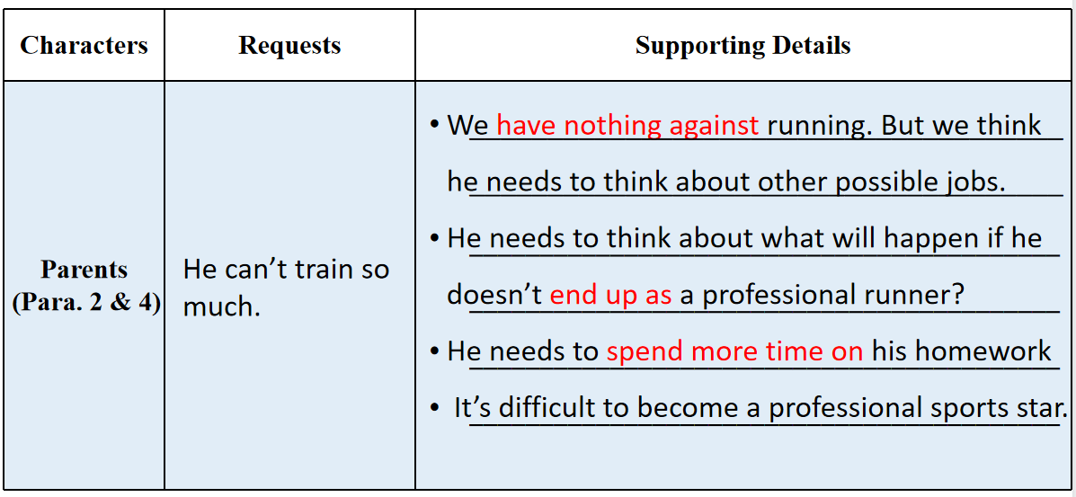
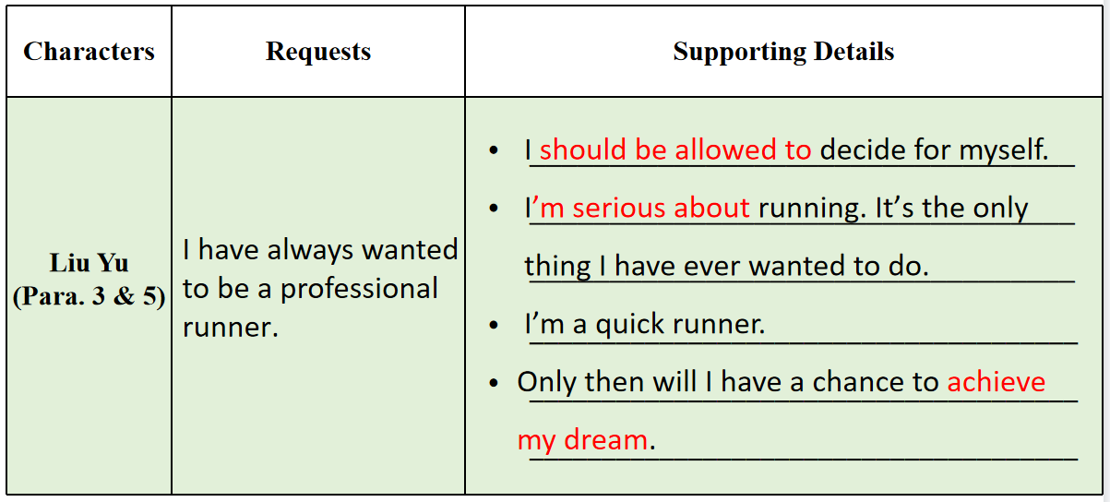
★Step 3 Think
Think and discuss: Do you think Liu Yu should be allowed to make his own decisions? Why or why not?
★Step 4 Speak
Express your own opinions and state the reasons.
★Step 5 Summary
- Give Liu Yu and his parents some advice.
- Enjoy a video and learn about how to make good use of your time.
★Step 6 Homework

Homework Feedback:
安庆市外国语学校西区

