一、单选题

1、在下列每组单词中，有一个单词的划线部分与其他单词的划线部分的读音不同。找出这个词。

A.Party

B.star

C.war

D.farm

答案：C

2.在下列每组单词中，有一个单词的划线部分与其他单词的划线部分的读音不同。找出这个词。

A.laugh

B.cough

C. Enough

D.though

答案：D

3.在下列每组单词中，有一个单词的划线部分与其他单词的划线部分的读音不同。找出这个词。

A.aunt

B.autuma

C.daughter

D.cause

答案：A

4.在下列每组单词中，有一个单词的划线部分与其他单词的划线部分的读音不同。找出这个词。

A.room

B.blood

C.zoo

D.food

答案：B

5.在下列每组单词中，有一个单词的划线部分与其他单词的划线部分的读音不同。找出这个词。

A.nice

B.pity

C.sit

D.fish

答案：A

6.would you like to visit peter with（）this weekend?

A.us

B.we

C.ours

D.our

答案：A

7.He is not using his phone,（） ?

A.does he

B.will he

C.is he

D.has he

答案：C

8.I took out my wallet, but there（）no money in it.

A.had

B.has

C.is

D.was

答案：D

9.I am excited （）we are going to the Great wall tomorrow.

A.that

B.but

C.or

D.which

答案：A

10.I can’t come out tonight（）I've got too much housework.

A.unless

B.because

C.although

D.until

答案：B

11.I（） basketball with my friends next weekend.

A.will play

B.play

C.have played

D.played

答案：A

12.The room（）I did my home work was too hot.

A.how

B.why

C.where

D.When

答案：C

13.She enjoyed （）how to look after young animals.

A.to learn

B.learnt

C.learning

D.Learn

答案：C

14.can we go home now?No.you（）

A.needn't

B.can't

C.dosen't

D.don't

答案：B

15.Jack came to china ten years ago. He has been Here（）than his brother.

A.longer

B.long

C.the longest

D.longest

答案：A

16.Jane（）as a doctor since 2005

A.will work

B.works

C.is working

D.has worked

答案：D

17.He was（）a book for his birthday

A.gives

B.give

C.given

D.giving

答案：C

18.Tina,_（）_the daughter of M. Smith, was born April last year.

A.to

B.in

C.on

D.at

答案：B

19.The shop owner told the driver（）his car

A.moving

B.move

C.moves

D.to move

答案：D

20.（）bike is this?I guess it's William's

A.Whom

B.Whose

C.What

D.Who

答案：B

二、问答题

1、

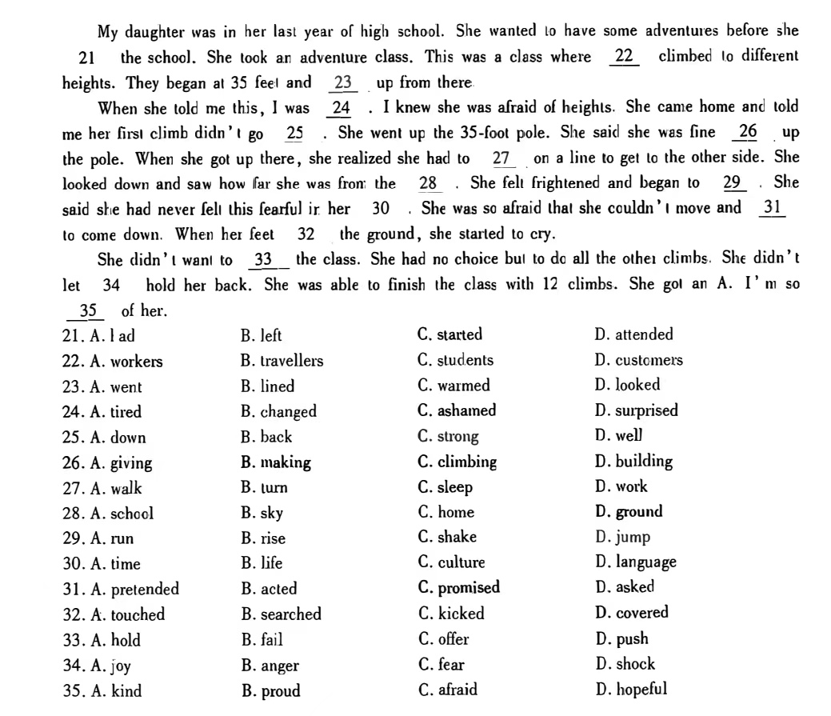



答案：

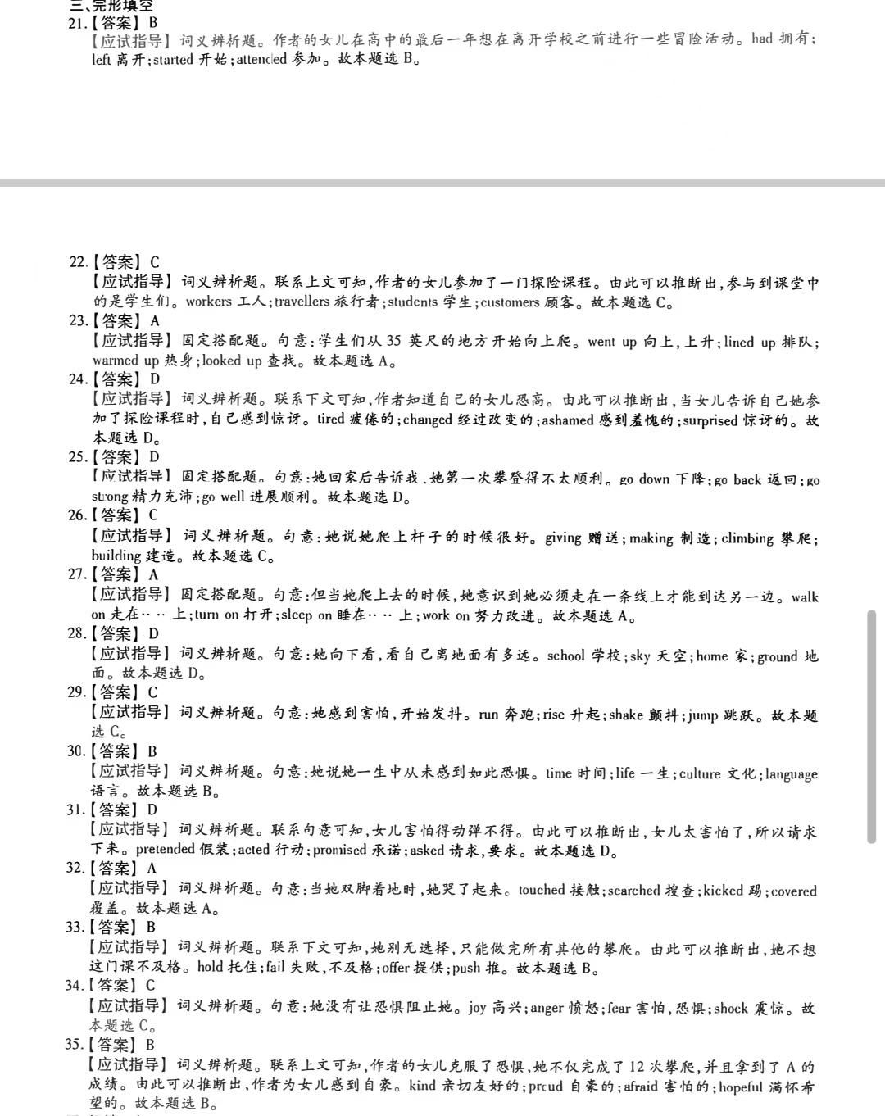

三、材料分析题

1、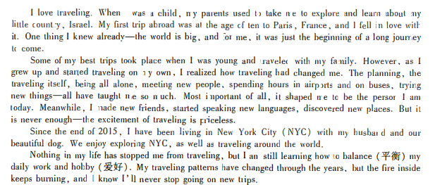

（1）（单）. What did the author do when she was ten years old?

A. She moved to Israel.

B. She left New York.

C. She took her first trip abroad.

D.She started to keep a pet dog.

答案：C

（2）（单）What is the autho r' s biggest gain from traveling?

A. It brought her to new places.

B. It taught her new languages

C. It offered her new friendship.

D. It made her who she is.

答案：D

（3）（单）What can we learn about the author from the last paragraph?

A. She will not stop traveling.

B. She hasn ' t changed her way of traveling,

C. She finds it difficult to control her anger.

D.She is good at balancing her hobby an d work.

答案：A

2、

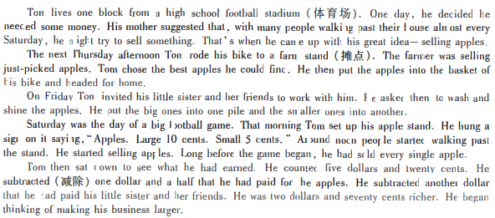

（1）（单） Where did Tom get the idea of selling apples?

A. From his sister.

B. From his mother.

C.From a

D. From a friend.

答案：B

（2）（单）When did Tom buy the apples?

A.On a Friday morning

B. On a Friday afternoon. .

C.On a Saturday morning

D. On a Thursday afternoon.

答案：D

（3）（单）What d id Tom do with the apples he brought home?

A. He put them into two groups .

B. He washed them one by on e .

C.He shined them with his sister

D.He kept them fresh in the basket. .

答案：A

（4）（单）How much money did Tom earn for himself?

A.$ 1 .

B. $1. 50.

C. $2.70.

D. $5.20.

答案：C

3.

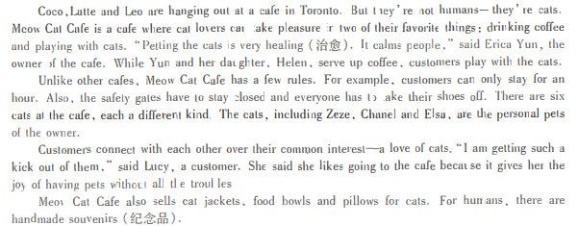

（1）（单）Coco , Latte and Leo are the names of

A. Cats

B. Cafes

C. shoes

D. foods

答案：A

（2）（单）What can customers do at Meow Cat Cafe?

A. They c an treat sick cats.

B. They can play with the cats.

C.They can learn to make coffee.

D. They can serve coffee to each other

答案：B

（3）（单）. Which of th e following is the rule made by Meow Cat Cafe?

A.Customers cannot feed the cats.

B. Everyone should take off their shoes. .

C. Everyone must go through a safety door.

D. Customers should stay for at least 1.5 hours.

答案：B

（4）（单）Why did Lucy say she loves going to the cafe?

A. She can go and see doctors there.

B. She ca n buy a ca t as her own pet.

C. She can buy jackets, bowls and pillows for her cats.

D. Sh e can p lay with the cats without looking after them .

答案：D

4、

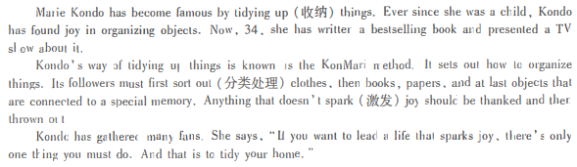

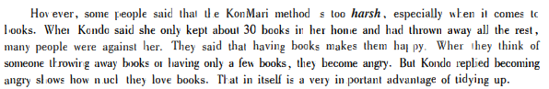

（1）（单）What did Kondo like doing in her childhood?

A. Watching TV

B. Reading books .

C. Holding parties.

D. Organizing things

答案：D

（2）（单）What kind of object should be sorted out first according to Kondo?

A. Bags.

B.Books.

C. Clothes.

D. Newspapers

答案：C

（3）（单）What does harsh in the fourth paragraph mean?

A. Cruel .

B.Silly.

C. Strange.

D. Useless.

答案：A

（4）（单）What is the passage mainly about?

A. Kon do' s fans.

B. Kondo ' s books.

C. The Kon Mari method.

D. The KonMari TV show .

答案：C

四、填空题

提示：Jack 碰到同学 Mike,两人聊起今晚的安排。

J: Hi, Mike. Are you doing anything special tonight?

M: （Nothing /No）

J: Good. I ' ve got two concert tickets. （Would you like to go with me）

M : Sure. I' d love to. （.How do we get there/ How can we go there）

J : We are going there by car. I will give you a ride.

M : Great. （When and where shallwe meet）

J : We 'll meet at the school gate. How ab out 6 o ' clock?

M: Okay. See you then.

J : （.See you）

五、问答题

假设你是李华。你想和英语老师Tom约时间在网上练习口语。请给Tom 写 一封电子邮件，内容包括：1.建议练习口语的时间；2.协商练习口语的网络平台。

注意：1.词数应为100 左右；2.邮件内容须写在答题卡的指定位置

答案：

