Unit 7 A Day to Remember
Period 4 Section B(1a-1d)
朱冬琴 安庆市外国语学校西区
Title | A Day to Remember
Theme | Man and self
Type | Reading
Analysis of the Overall Unit | 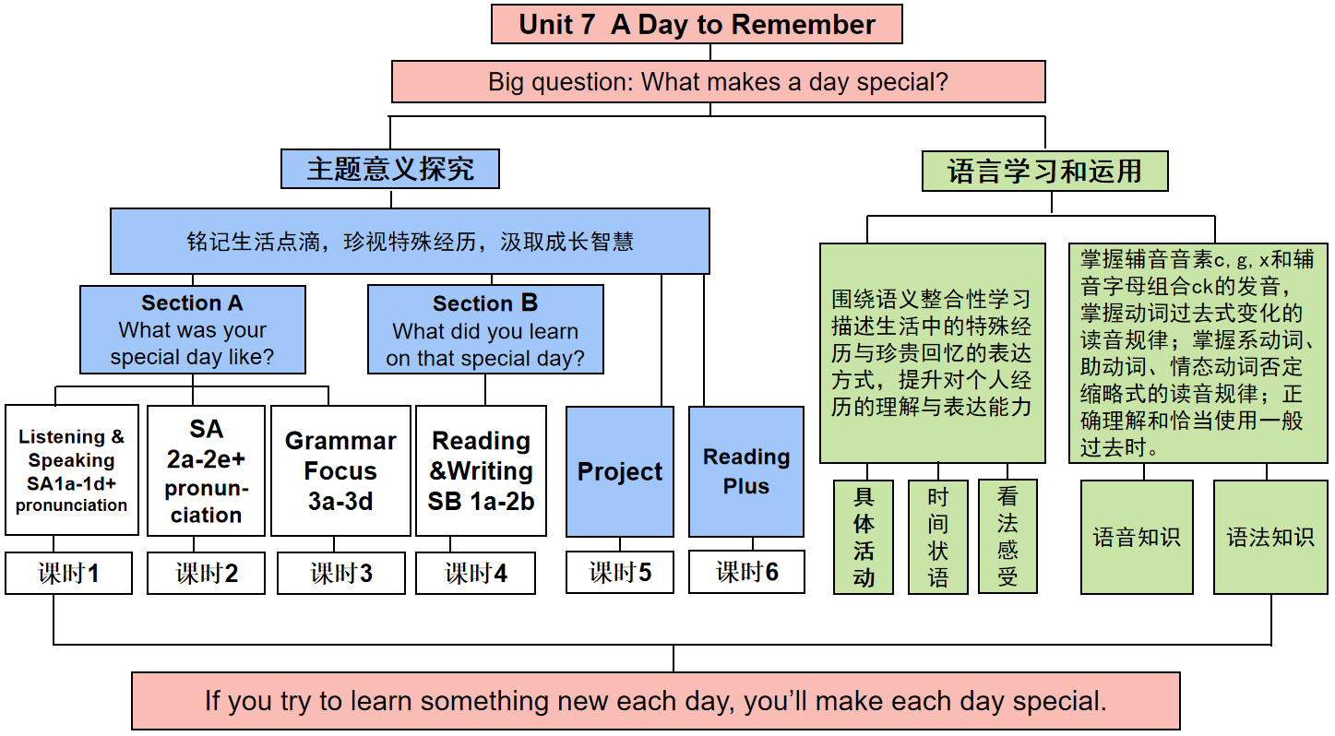
Analysis of Teaching Material | What | The reading text of this lesson is a diary, which is Sam's record of his feelings and gains from the farm visit activity.
 | Why | This lesson aims to convey the significance and value of labor education through students' farm travel experiences, as well as the importance of deepening understanding and respect for agricultural labor through personal experiences.
 | How | A diary is a form of narrative writing, mainly following the thread of time to record an individual's thoughts, feelings, experiences and what they have seen and heard.A diary is a form of narrative writing, mainly following the thread of time to record an individual's thoughts, feelings, experiences and what they have seen and heard.While describing the activities he participated in, Sam also expressed his feelings and understanding.
Analysis of Students | What Ss knew | Students have no trouble in understanding the simple past tense.
 | What Ss wonder | Students are interested in and curious about the farm, so that they are willing to read the passage and produce new ideas through cooperation. However,they have limited information about the farm and are lack of practice of reading skills and strategies. So they expect to read more and practice more.
 | What Ss will learn | Students will learn more Words related to farms and Understood the relevant expressions of the agricultural production process.Also,they will learn the basic format and structure of a diary, as well as how to describe around an experience.
Teaching  Objectives | By the end of the class, students will be able to:  1.Language ability  Students were able to understand and apply vocabulary and sentence patterns related to diaries and farm activities.  2. Cultural awareness  Understand the process and importance of farm labor, and understand the concept that labor creates value.  3. Thinking quality  Encourage students to think about the meaning and value of farm labor, and cultivate students' critical thinking.  4. Learning ability  Through reading and discussion, students are trained to obtain information, analyze and solve problems.
Teaching Key and Difficult Points | Teaching key points:  1.Master vocabulary and phrases related to farm activities.  2.Understand the content of the diary and be able to answer relevant questions.  Teaching difficult points:  Learn to retell the diary.
Teaching  Approaches | 1. Activity-based Teaching Approach  2. Communicative Teaching Approach  3. Cooperative Learning Approach
Teaching  Aids | 1. A multimedia computer system  2. Blackboard
Layout
Activities |  |  |  | Levels of activities | Levels of reading
Lead in | Free talk:  What did Sam do? |  |  | 学习理解类  （总结与整合） | 创设情境  导入主题
Read and think | 1.Listen and match each paragraph with its main idea.  2.Read for specific information |  |  | 学习理解类  （获取与梳理） | 解读文本  感知主题
 | 3.Read and find out three key words that each passage infers.
Express yourself | Share ideas about why food tastes better when you work for them. |  |  | 迁移创新类  （分析与评价） | 拓展探究  升华主题
Think and explore | 1.Retell the diary.(discuss in groups)  2. Summarize and make a conclusion that we should avoid wasting food and cherish farmers' hard work. |  |  | 迁移创新类  （创造与应用）
Teaching procedures
Steps | Activities
Step 1  Lead‐in | Activity 1  Be a careful observer |  | Students are supposed to watch a short video clip and talk about what Sam did.
Step 2  Pre-reading | Activity 2  Be an active speaker |  | 1.Look and say  When was it?  What did Sam do in his diary?  2.Have a discussion about keeping a diary.
Step 3  While-  reading | Activity 3 Be a good listener |  | 1.Read Sam’s diary quickly and answer the question---What’s this diary about?(Topic sentence)  2.Know about five elements of the narrative(diary).  3.Students listen and match each paragraph with its main idea.
 | Activity 4  Be a careful reader |  | 1.Students read the first paragraph carefully and answer the question.(underline the key sentences.)  2.Students read the second paragraph carefully and underline the verb phrases.  3.Students read the third paragraph carefully and answer the questions.  4. Students discuss and share ideas about why food tastes better when you work for them.
Step 4  Post-  reading | Activity 5  Be a wise reader |  | Learn to retell the diary in groups.
 | Activity 6 Be a clever explorer |  | Summarize and make a conclusion that we should avoid wasting food and cherish farmers' hard work.
 | Homework |  | You must do:  1.Retell Sam’s diary entry according to the mind map.  2.Finish the exercisebook Period 4  You can do:  1. Try to exchange your retelling with your partner and try to polish for each other.  2. Search for one kind of crop like corn,wheat and so on, and describe the process of its growing in English.
Blackboard  Design | 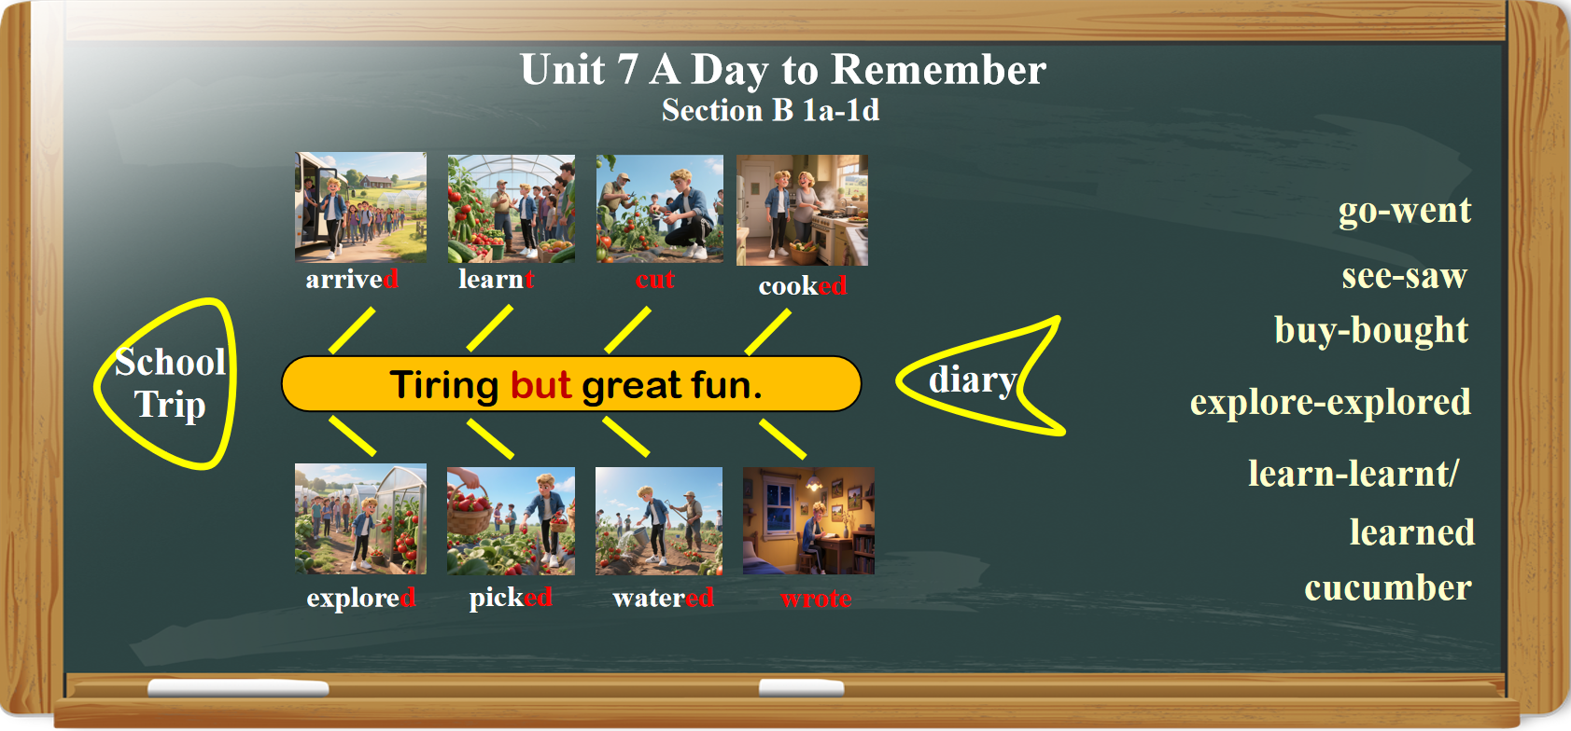
Teaching reflection | Highlights  1.Going smoothly and reach the teaching objectives;  2.Fully involved;  3.A deep understanding of the passages by a little push and positive evaluations.  Improvement  1.Insufficient discussion.

