Teaching Plan From Ada Liang Nov.25th,2025
单元名称 | Unit5.What a Delicious Meal!
教学课时 | Period 4 Section B 1a-1f
单元主题 | 主题范畴：人与社会 主题群：饮食文化与情感联结 子主题：食物承载的记忆、爱与跨文化理解
语  篇  研  读 | What  (主题意义，主要内容) | 1. 文本类型：记叙文（个人回忆）  2. 核心内容：  - 作者通过南瓜派回忆祖母的厨房时光  - 祖母在美国寄宿家庭学习制作南瓜派的经历  - 食物传递爱与跨文化友谊的主题  3. 关键概念：  - 文化符号：感恩节（Thanksgiving）、肉桂（cinnamon）  - 核心短语：thanks to, share with, make friends, secret to cooking
语  篇  研  读 | Why  (作者意图，育人价值) | 1. 情感价值：  - 理解“烹饪是爱的可视化”（Cooking is love made visible）  - 体会食物联结亲情与记忆的功能  2. 文化价值：  - 认同跨文化交流的意义（making friends through food）
语  篇  研  读 | What  (文本结构，语言修辞) | 1. 文本结构：回忆线索：祖母的厨房→食谱起源→跨文化启示  2. 语言特征：  - 感官描写：smell of cinnamon filled the room  - 隐喻修辞：food connects cultures  - 情感表达：What wonderful memories I have!
学  情  分  析 | Know | Want | Learn
学  情  分  析 | 1. 已掌握基础食物词汇（pumpkin, pie）  2. 能理解简单记叙文的时间顺序  3. 熟悉“家庭”主题相关表达（如 grandmother, kitchen） | 1. 渴望学习食物背后的文化故事  2. 希望用英语表达情感记忆  3. 对“秘密食谱”“跨文化友谊”概念感兴趣 | 1. 语言能力：  - 理解 thanks to/share with 等短语  - 用感官词汇描述食物记忆（smell/taste）  2. 文化意识：  - 认同“食物传递爱”的普世价值  3. 思维品质：  - 分析文本隐喻（P.I.E = Pumpkin, Instruction, Expression）
教学目标
1. Master key words (memory, cinnamon, recipe, crust) and phrases (warm up, according to) for daily use.
2. Proficiently use exclamatory sentences and distinguish countable/uncountable nouns in them.
3. Understand the link between food, love and culture, and value family affection.
教学重难点
- Key Points: Grasp key vocabulary, exclamatory sentences and the text’s main idea.
- Difficult Points: Interpret "Cooking is love made visible" and express food-love stories in English.
Teaching Resources |  | 课件PPT，听力视频
Teaching Methods |  | 情境教学法、任务驱动法、合作探究法
Teaching Procedures
1. Lead-in (5 Minutes)
- Ask: “What’s your favorite homemade dish? Who cooks it for you?” Invite 2 students to share.
- Present the theme sentence “Cooking is love made visible” to introduce the lesson.

2. Pre-reading (6 Minutes)
- Teach key words/phrases via flashcards, with pronunciation drills and simple example sentences.
- Let students predict the text content based on the title “Food for Thought”.

3. While-reading (15 Minutes)
- Fast reading: Students confirm the text type and main idea .
- Detailed reading:
- Para.1: Complete the mind-map of why the writer loves cooking.
- Para.2: Answer questions about grandma’s pumpkin pie (making time, kitchen features, memory trigger).
- Para.3: Judge T/F about the pumpkin pie recipe’s origin.
- Para.4: Sort the 5 steps of making pumpkin pie.
- Para.5: Fill in blanks about cross-cultural food and cooking secrets.

4. Post-reading (10 Minutes)
- Think: What is grandma like? What does cooking bring to students?
- Pair discussion: Share personal food-love stories, guided by the question “How does food carry love in your life?”.

5. Summary & Homework (4 Minutes)
- Summary: Love is in small, everyday actions.
- Homework:
1. Recite key words and sentences.
2. List English ingredients and steps of a favorite simple dish.
3. Optional: Interview parents about their favorite food and write a short passage.
评价反馈 |  | 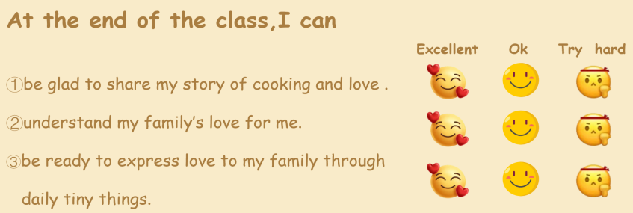
板书设计 |  | 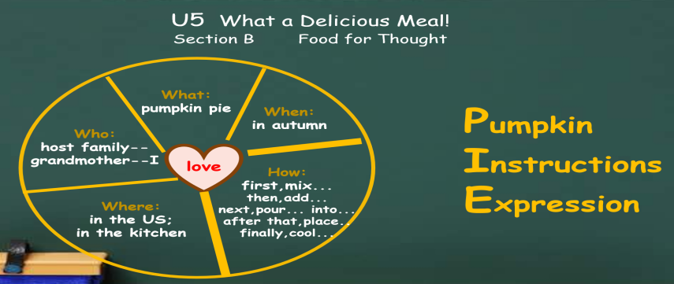
教学反思 |  | - 课堂氛围不够活跃；  - 板书内容稍少；

