Unit 5 What a Delicious Meal!
Period 4 Section B(1a-1f)教学设计
朱冬琴
Title | What a Delicious Meal!
Theme | Man and self
Type | Reading
Analysis of the Overall Unit | 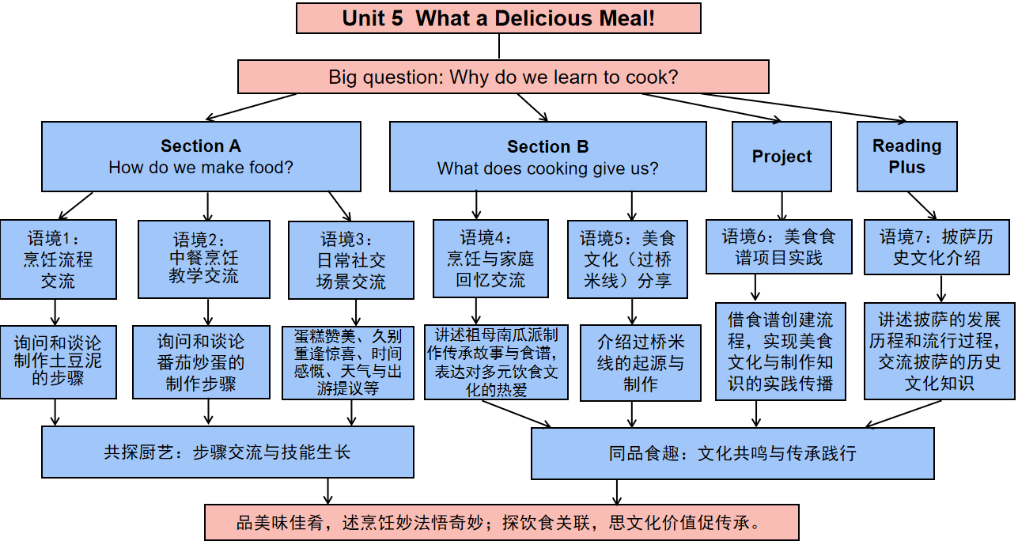
Analysis of Teaching Material | 【What】  本课语篇是一篇兼具抒情性与叙事性的散文Food for Thought，搭配梯度化练习活动，构建“感知观点 - 梳理记忆 - 实践应用 - 情感分享”的学习架构。语篇以“烹饪是爱的具象化”(Cooking is love made visible)为核心主线，按“提出观点 - 讲述回忆 - 提炼感悟”的逻辑展开:开篇引用祖母的话点明核心观点，阐述烹饪是分享爱的方式，以及家人围坐用餐时食物如何联结情感、创造回忆;中间部分以“祖母的南瓜派”为叙事载体，详细描述南瓜派的季节意义(秋日暖食)、感官记忆(肉桂香气)、起源故事(美国寄宿家庭学习制作)，通过具体场景唤起共鸣;结尾回归祖母的跨文化饮食态度，强调“带着爱烹饪”的秘诀，以及这种理念对“我”的影响- 乐于尝试不同文化的美食与食谱。语篇中自然融入“pumpkin pie、cinnamon、recipe、host family”等饮食与生活相关词汇，以及“thanks to、along with”等逻辑连接词，同时穿插“What wonderful memories I have!”等感叹句，兼具语言示范性与情感感染力。  【Why】  此语篇通过“观点+叙事”的形式，旨在让学生在语言学习中感知食物与情感的深层联结，达成“语言能力提升 -思维品质发展-情感态度培育”的多元目标。语篇提供了丰富的生活场景词汇，为学生描述饮食体验、表达情感提供语言范例;通过“祖母的南瓜派”这一私人回忆，传递“食物承载亲情与爱”的温暖理念，引导学生关注日常生活中的情感细节;祖母学习跨文化美食的态度，则渗透“开放包容”的文化观，让学生理解食物是文化交流的载体。  【How】  语篇采用“抒情叙事结合”的风格，兼具真实性与感染力，练习设计贴合语篇特点，为教学提供清晰实施路径。以“个人回忆”为载体，帮助学生理解和运用语言；采用任务型教学法，设计不同问题，让学生在完成任务中学习；结合阅读训练、角色扮演等方式，提升学生的语言运用能力。
Analysis of Students | K（已知）：已经具备一定的英语基础，能理解简单的英语对话和指令。他们能理解关于家庭、烹饪回忆这类贴近生活的内容并且凭借日常认知和简单的英语阅读能力，可较好把握情感脉络。同时，对于常见的食材类词汇（如 “eggs”“sugar”“cinnamon” 等）以及基础的烹饪步骤类表达（如 “mix”“add”“pour” 等），有一定的认知基础，能识别并理解这些词汇在语境中的含义。  W（想知）：可能会对不同文化背景下的美食更感兴趣，比如文中提到祖母从其他文化学习美食制作，学生或许会好奇更多不同国家的特色食物及其背后的文化故事。另外，对于更复杂的句子结构和一些稍抽象的表达，比如 “Cook with love.” 这种蕴含哲理的句子，学生可能想深入探究其内涵，以及如何更准确地理解和运用这类表达。  L（将知）：在后续学习中，学生可以进一步学习不同文化相关的美食词汇和表达，拓展词汇量。同时，能更深入地理解通过食物传递情感、连接文化的意义，提升对跨文化内容的理解能力。还可以学习更丰富的句子结构，来更准确、生动地描述烹饪过程、情感体验以及文化现象等，提高英语的综合运用能力。
Teaching  Objectives | （一）语言能力  -能准确提取语篇中关于南瓜派制作背景、祖母烹饪理念的关键信息并能用简单复合句复述故事主要情节。  -能理解并运用主题词汇描述食物制作过程及情感关联。  （二）文化意识  -通过祖母学习美国南瓜派的故事，初步感知中西方饮食文化的差异与共通性——食物承载情感是跨文化共通点。  -认同开放包容的文化态度，理解通过美食结交朋友体现的跨文化交际价值——美食连接世界。  （三）思维品质  -能按时间顺序梳理祖母学习制作南瓜派→影响作者的事件逻辑，区分事实信息与情感表达。  -通过对比作者与祖母的烹饪经历，初步培养从个人经验到文化传承的关联思维——食物是代际情感的载体。  （四）学习能力  -能运用圈划关键词、制作时间轴等策略自主梳理语篇结构。  -能在小组合作中主动分享食物与爱的个人经历，借助思维导图整合他人观点，完善自我表达。
Teaching Key and Difficult Points | 【重点】  1.理解文本内容,提取文本关键信息,完成相应的题目。  2.能够在不同的活动中，锻炼其不同方面的能力。  【难点】  1.使用恰当流畅的语言描述自己对于食物与爱的回忆。
Teaching procedures
Steps | Activities
Step 1  Lead‐in | 1.Prepare three “smell memories blind boxes” with different scents (lemon,vinegar,cinnamon).  Invite students to smell the scents and share what memories or feelings they evoke.  2.Invite students to answer “What’s your favourite dish?”and “Who made it for you?”
Step 2  Pre-reading | 1.watch the video and guide students to know what the writer’s favourite dish is and who made it for her.  2.Discuss the meaning of the title.
Step 3  While-  reading | 1.Fast reading  1).Tick the best main idea: Instruct students to skim the text quickly and tick the best main idea: "Through food and cooking, we create memories and show love to others."  2).Read and match the main ideas with each paragraph.
Step 3  While-  reading | 2.Careful reading  1).Para.1  ①Guide students to read Para 1 carefully and answer the questions provided.  Why does the writer love cooking?  How do you understand “Cooking is love made visible?”  ②Guide students to summarize the topic:Cooking shares love.  2).Para.2  ①Guide students to read Para 2 carefully and fill in the blanks,and try to feel the writer’s emotion from four aspects(who/when/where/how),which echoes what Grandma said “Cooking is love made visible” .  ②Guide students to summarize the topic:Cooking carries memories.And “family love”,which becomes visible in cooking.  3).Para.3  ①Guide students to read Para 3 carefully and complete the mindmap,and draw a conclusion that “others’ love” is visible in cooking.  ②Guide students to read the recipe and put the pictures in the correct order.  ③Retell the instructions according to the pictures.  4).Para.4  ①Guide students to read Para 4 carefully and fill in the blanks.  ②Guide students to summarize the topic: Cooking connects love and cultures.And world love.
Step 4  Post-  reading | 1.Further thinking:What kind of person do you think the writer’s grandma is according to the text?  2.Write a memory the students have of food and love and share.
Step 5  Homework | Must do:  Beautify your passage and share it with us tomorrow!  Try to do:  Make a video about cooking your favourite food,and share it with your family and friends.
Blackboard  Design | 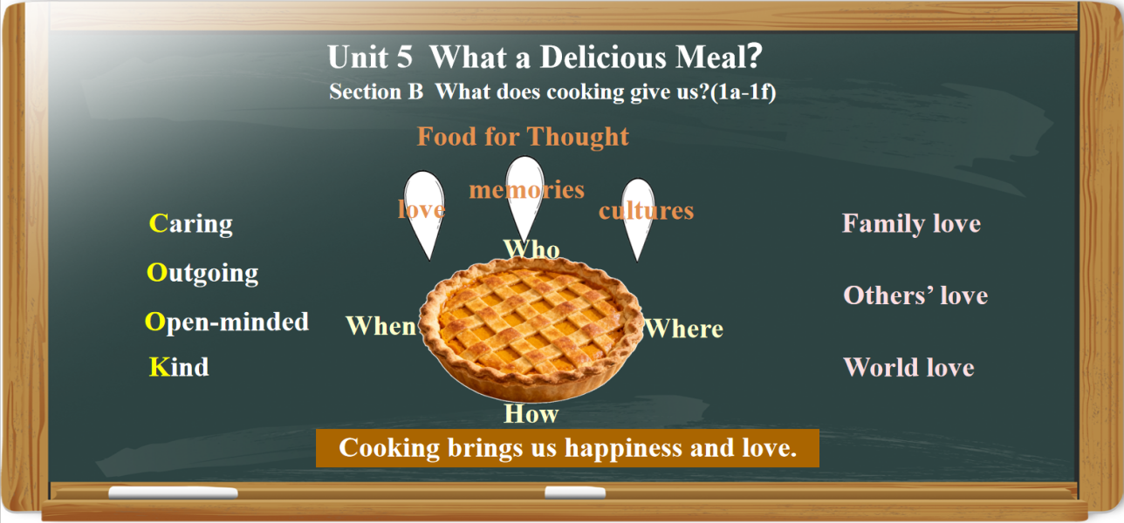
Teaching reflection | Highlights  1.Going smoothly and reach the teaching objectives;  2.Fully involved;  3.A deep understanding of the passages by a little push and positive evaluations.  Improvement  1.Insufficient writing.

Learning Sheet

Activity 1 Free talk: What’s your favourite dish?
Who often makes the dish for you?

Activity 2 1b
Read the text and tick the best main idea.
□ Through food and cooking we create memories and show love to others.
□ It is fun to learn how to make food from other cultures.
□ I have wonderful memories of my grandmother's kitchen.
Activity 3 Fast reading
Read and match the main ideas with each paragraph.
Para. 1 My memory of my grandmother's pumpkin pie
Para. 2 The meaning of cooking
Para. 3 Grandma's lesson and influence(影响)
Para. 4 My grandmother’s first pumpkin pie
Activity 4 Careful reading

1.Para.1
⑴. Why does the writer love cooking?
A.Because it’s a great way to share love.
B.Because it’s a great way to create memories.
C.Because it’s a great way to help others.
(2). How do you understand “Cooking is love made visible？”

A.Cooking is a way to show love.
B.Love can be seen when cooking.
C.Cooking makes love disappear.

2.Para.2

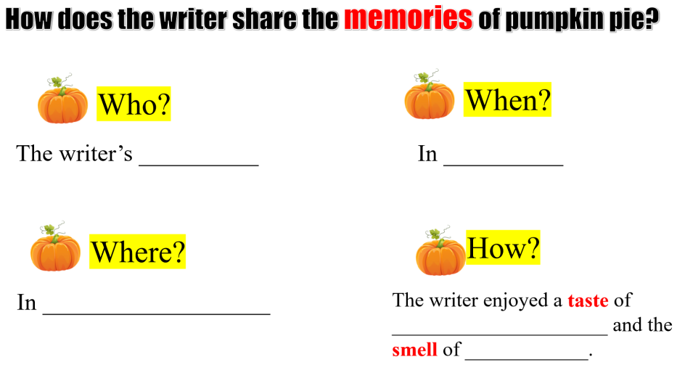

3.Para.3
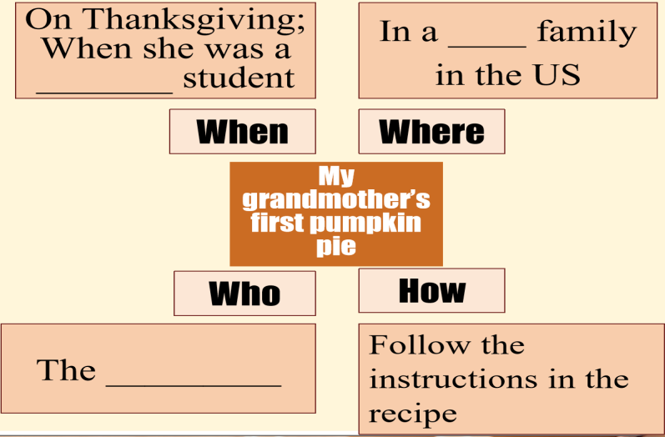
4.Para.4
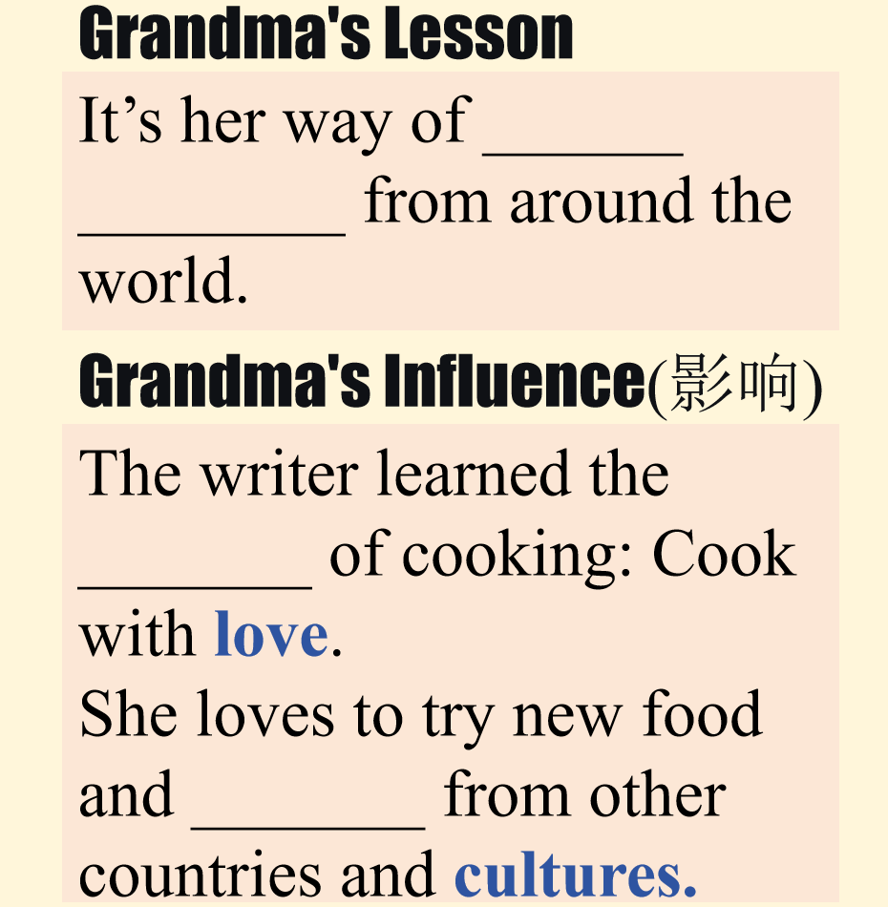

Activity 5 Write a memory you have of food and love.

My favourite food is_________________.______________ often makes the dish for me and he/she is really good at it.
One of my favourite memories is the time when ________________________
___________________.His/Her friendly kitchen was the perfect place to __________
____________________.______________________________________________________________________________________________________________________
Now,every time I smell ___________,I think of my ____________.
______________ taught me the secret to cooking: _______________________.
Come and try the new recipe with me,and I’m sure you’ll love it.

